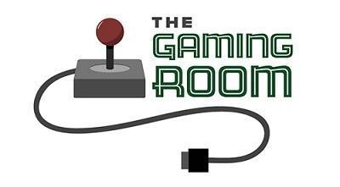

Draw It or Lose It

CS 230 Project Software Design Template
Version 1.0

Table of Contents

CS 230 Project Software Design Template 1
Table of Contents 2
Document Revision History 2
Executive Summary 3
Requirements 3
Design Constraints 3
System Architecture View 3
Domain Model 3
Evaluation 4
Recommendations 5

Document Revision History

Version | Date | Author | Comments
1.0 | <06/06/26> | Rajesh Tekumulla | Initial draft of the software design document for Draw It or Lose It.

Instructions
Fill in all bracketed information on page one (the cover page), in the Document Revision History table, and below each header. Under each header, remove the bracketed prompt and write your own paragraph response covering the indicated information.

Executive Summary

The client, The Gaming Room, is trying to build a web-based game that works on different platforms, based on their Android app Draw It or Lose It. The app is gonna show images from a big library of stock drawings so teams can guess what it is instead of drawing on an easel. Before we do the hardware stuff, the client definitely needs to know that the software application decisions have to be made first to streamline the development.

Requirements

The game has to support one or more teams playing.

Each team is gonna have multiple players assigned to it.

Game and team names must be unique so users can check if a name is already taken.

Only one instance of the game can exist in memory at any given time.

Design Constraints

Web-based environment: We have to build the game application in a web-based distributed environment so it can serve multiple platforms instead of just Android.

Singleton Pattern: Since we can only have one instance of the GameService class in memory at any time, we have to use the singleton pattern.

Iterator Pattern: To make sure there are no duplicate instances when a game is saved, we have to use an iterator pattern to check every game instance already in play to see if the name is used.

System Architecture View

Please note: There is nothing required here for these projects, but this section serves as a reminder that describing the system and subsystem architecture present in the application, including physical components or tiers, may be required for other projects. A logical topology of the communication and storage aspects is also necessary to understand the overall architecture and should be provided.

Domain Model

Inheritance: The Game, Team, and Player classes all inherit from the Entity base class.
Encapsulation: The Entity class holds the common attributes like 'id' and 'name' so we dont have to write it over and over.

Singleton Pattern: The GameService uses a private constructor and a static variable to make sure only one instance exists in memory.

Iterator Pattern: We use Java's provided iterator to loop through our lists and check that names are unique before adding new ones.

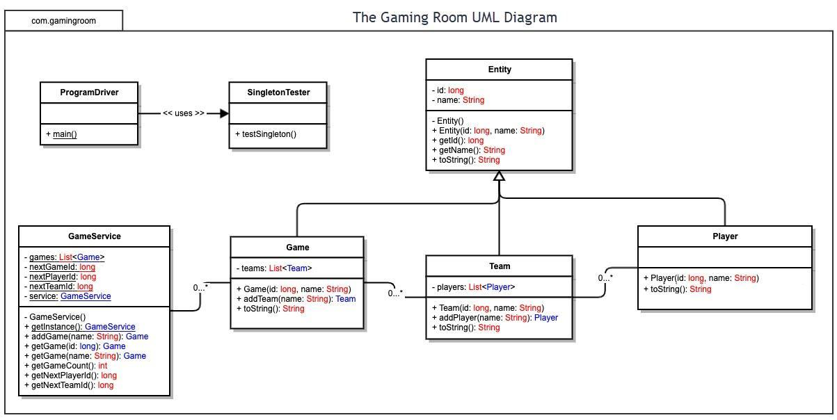

Evaluation

Using your experience to evaluate the characteristics, advantages, and weaknesses of each operating platform (Linux, Mac, and Windows) as well as mobile devices, consider the requirements outlined below and articulate your findings for each. As you complete the table, keep in mind your client’s requirements and look at the situation holistically, as it all has to work together.

In each cell, remove the bracketed prompt and write your own paragraph response covering the indicated information.

Development Requirements | Mac | Linux | Windows | Mobile Devices
Server Side | Apple macOS servers are capable environments but generally entail high initial capital expenditures for proprietary hardware. They are less commonly utilized for hosting highly scalable, distributed web applications compared to enterprise alternatives. | Linux is an industry standard for web hosting, offering exceptional scalability, robust security, and cost efficiency as an open source platform. It is highly recommended for hosting a server based web deployment, though it requires administrative expertise in command line interfaces rather than standard GUIs. | Windows Server provides a highly integrated and user friendly environment. However, it requires commercial licensing fees, which will increase the ongoing operational costs for The Gaming Room. | Mobile devices are unsuitable for server side hosting. They lack the necessary hardware redundancy, thermal management, high bandwidth network connectivity, and processing power required to host a web application scaling to thousands of players.
Client Side | Client delivery on macOS will be achieved via modern web browsers (e.g., Safari, Chrome). The primary development consideration is ensuring responsive HTML/CSS design that functions smoothly across Apple's display standards rather than building a native desktop application. | Similar to Mac, Linux clients will access the application exclusively through web browsers like Firefox or Chrome. Development efforts must focus on maintaining standard HTML5 web compatibility, ensuring cross-browser functionality regardless of the user's specific Linux distribution. | Windows clients will utilize standard desktop web browsers (Edge, Chrome). As the vast majority of desktop gamers operate on Windows, extensive cross browser testing on this OS is critical to ensure a seamless and responsive frontend user experience. | Moving beyond the current Android app requires supporting both iOS and Android. Expanding to mobile clients requires adapting the responsive web interface for touch controls and smaller screen resolutions, ensuring parity with the desktop web experience.
Development Tools | Developing potential native iOS components or testing macOS browser compatibility requires Apple hardware and tools like Xcode(Swift/Objective-C)  Impact on Team: The Gaming Room will require developers specifically skilled in the Apple ecosystem. A specialized iOS/Mac team or dedicated contractors may be necessary. | Linux is ideal for backend server development using IDEs like Eclipse or IntelliJ (Java, Python, C++).  Impact on Team: A dedicated backend development team with Linux system administration skills will be required to build, deploy, and maintain the distributed server architecture | Visual Studio is the premier IDE for Windows, supporting robust backend or frontend development. Impact on Team: The cross platform nature of this project strongly suggests dividing the workload. The Gaming Room will likely need multiple teams: a backend server team, a frontend web team, and potentially a mobile team. | Android Studio (Java/Kotlin) and Xcode (Swift) are standard for mobile. Alternatively, cross platform frameworks like React Native or Flutter could be utilized.  Impact on Team: Adopting cross platform mobile tools could reduce staffing costs by allowing a single, versatile mobile team to deploy to both iOS and Android simultaneously.

Recommendations

Analyze the characteristics of and techniques specific to various systems architectures and make a recommendation to The Gaming Room. Specifically, address the following:

- Operating Platform: A web-based distributed environment is recommended to allow The Gaming Room to expand Draw It or Lose It to multiple computing environments.

- Operating Systems Architectures: The architecture involves transitioning from a single-platform Android application to a web-based distributed format capable of serving multiple client platforms.

- Storage Management: The provided materials do not explicitly detail an appropriate storage management system to be used for this project.

- Memory Management: The application's memory management dictates that only one instance of the GameService class can exist in memory at any given time, which is accomplished by implementing the Singleton design pattern.

- Distributed Systems and Networks: The software will operate in a distributed web environment, relying on standard HTTP/HTTPS protocols to facilitate realtime communication between the client web browsers/mobile apps and the centralized backend server.

- Security: To protect user information and maintain integrity across platforms, standard web security practices should be implemented. This includes enforcing HTTPS encryption for all data in transit.

